ECE0202: Embedded Systems and Interfacing
Lab 5: Stepper Motor Control (in assembly)

Objectives
- Use full stepping to control the speed and position of a stepper motor
- Generate pulse waveforms to control a stepper motor
- Use Darlington transistor arrays to perform high-current driving with extremely low input current
Pre-Lab Reading
- Read Textbook Chapter 16: Stepper Motors
- Watch the following video tutorials (credit to pcbheaven):
  - http://www.youtube.com/watch?v=MHdz3c6KLrg
  - http://www.youtube.com/watch?v=t-3VnLadIbc
- Answer the pre-lab questions

Deliverables
- (40 points) Basic requirement: Code that operates a simulated “windshield wiper” on the stepper motor.
  - When the on-board button(blue) is held down, the stepper motor will rotate approximately 145$°$ counterclockwise, then 145$°$ clockwise, then repeat over and over. When the button is released, the “windshield wiper” should finish its current routine and stop when it returns to 0$°$.
- (10 points) Answers to the pre-lab questions. Indicate how each group member participates and contributes to the lab at the end of the lab report.
- (50 points) A demonstration of the operational circuit to an instructor or TA.

Please submit your code and pre-lab answers and your Circuit photo as a pdf to Black board.

Stepper Motor Overview
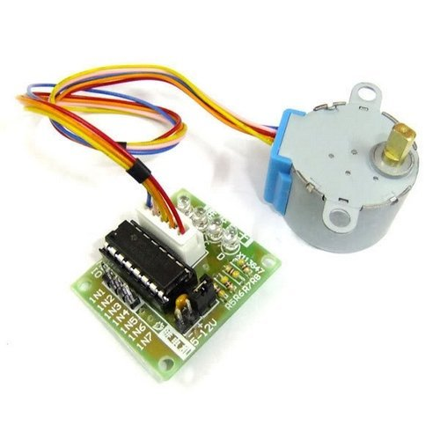 |  | 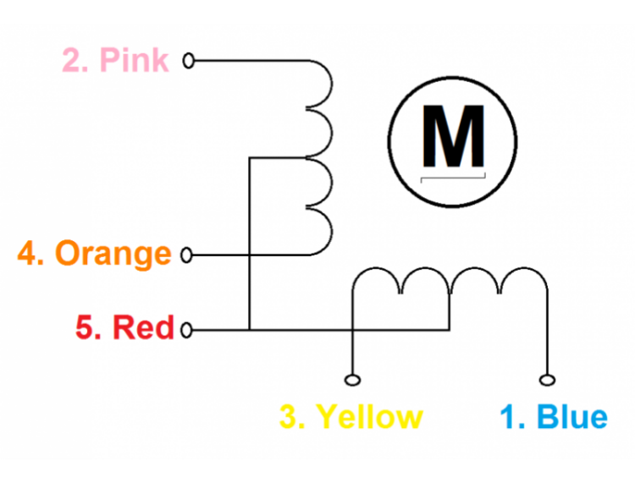
Motor model | 28BYJ-48 |  | Number of phases | 2
Rated voltage | 5V DC |  | Geared reduction ratio | 1/64
DC resistance per phase | 50Ω±7%(25℃) |  | Pull in torque | >300gf.cm / 5VDC 100pp
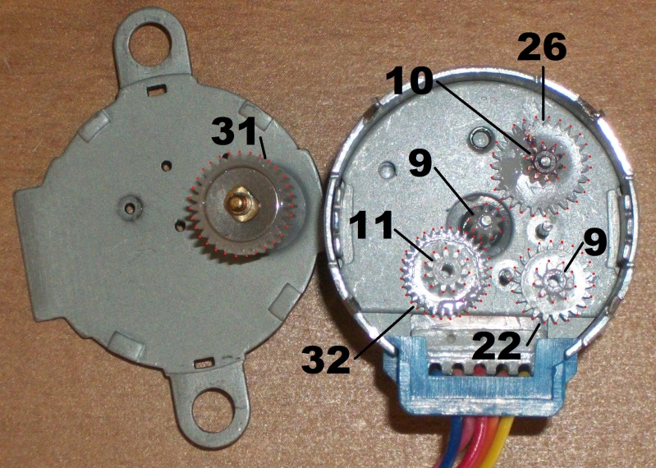
image from forum.arduino.cc

The gear ratio is:
$$\frac{31×32×26×22}{11×10×9×9}=63.68395$$

Full-stepping
- Internal motor: 32 steps per revolution
- Great reduction ratio: 1/63.68395, approximately 1/64
- So it takes $32×64=2048$ steps per revolution for the output shaft

Half-stepping
- Internal motor: 64 steps per revolution
- Great reduction ratio: 1/63.68395 ≈ 1/64
- So it takes $64×64=4096$ steps per revolution for the output shaft

Interfacing the stepper motor requires four pins. We select the following four pins to control the stepper motor: PB2, PB3, PB6, and PB7. The textbook provides a connection diagram for stepper motor Mabuchi #PF35T, which is very similar to the diagram below.

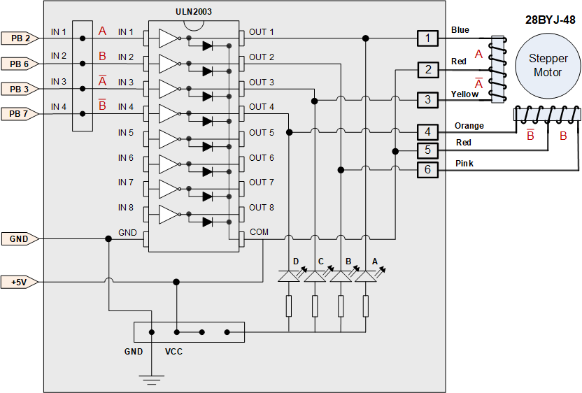
+
-

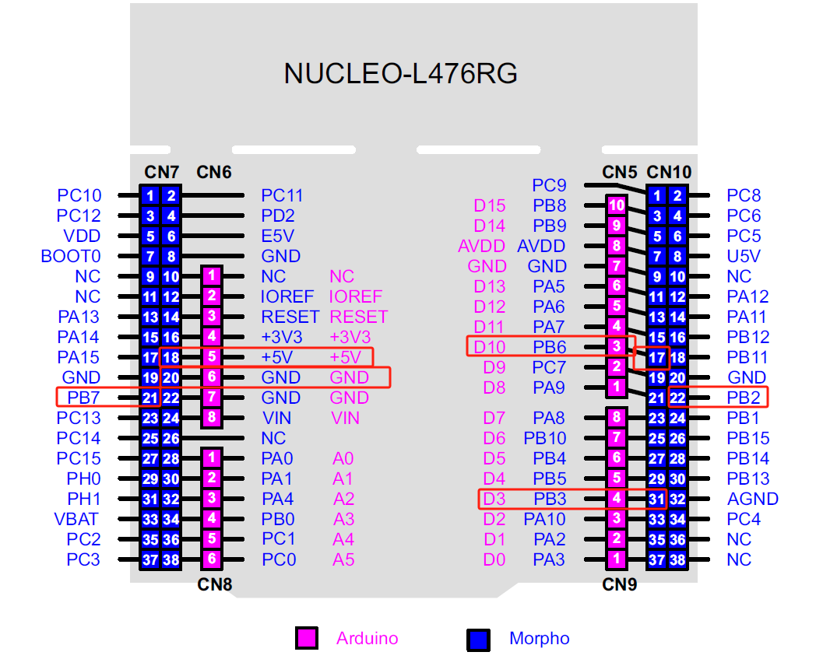

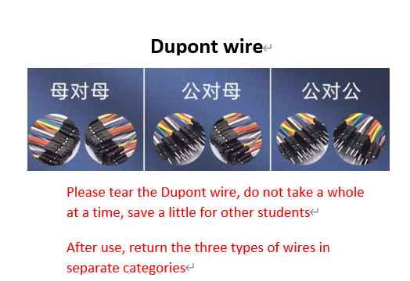

Pre-Lab Questions

- Fill out the following timing diagrams for the GPIO outputs that create a full-stepping sequence and a half-stepping sequence.
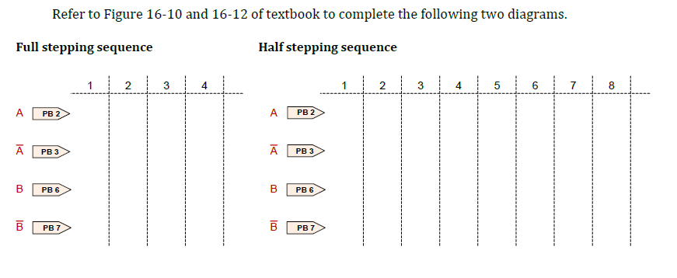

- How would you change your code to vary the rotation speed of the stepper motor?

- How would you reverse the rotation direction of the stepper motor?

Participation and Contribution

Please indicate the participation and contribution for each group member using the following table.

Name | Participation and Contribution

